**INTI International College Penang School of Engineering and Technology**

**3+0 Bachelor of Science (Hons) in Computer Science, in collaboration with Coventry University, UK**

**3+0 Bachelor of Science (Hons) in Computing, in collaboration with Coventry University, UK**

**Coursework cover sheet**

**Section A - To be completed by the student**

|  |  |
| --- | --- |
| Full Name: **ARSYAD HASSAN BIN SEGU HASAN GANI** | |
| CU Student ID Number: **P22014749** | |
| Semester: **1** | |
| Session:  **August 2022** | |
| Lecturer:  **Nadhrah Abdul Hadi (nadhrah.abdulhadi@newinti.edu.my)** | |
| Module Code and Title:  **4067CEM Software Design** | |
| Assignment No. / Title:  **Continuous Assessment** | % of Module Mark:  **50** |
| Hand out Date:  **6th September 2022** | Due Date:  **Task 1: 30 September 2022, by 11.59pm.**  **Task 2: 18 November 2022, by 11.59pm**  **Task 3: 18 November 2022, by 11.59pm.**  **Task 4: 18 November 2022, by 11.59pm.**  **Task 5: 18 November 2022, by 11.59pm.** |
| Penalties: No late work will be accepted. If you are unable to submit coursework on time due to extenuating circumstances, you may be eligible for an extension. Please consult the lecturer. | |
| Declaration: I/we the undersigned confirm that I/we have read and agree to abide by the University regulations on plagiarism and cheating and Faculty coursework policies and procedures. I/we confirm that this piece of work is my/our own. I/we consent to appropriate storage of our work for plagiarism checking.  Signature(s): ________ARSYAD________________ | |

**Section B - To be completed by the module leader**

|  |  |  |
| --- | --- | --- |
| Intended learning outcomes assessed by this work:  1. Understand and apply appropriate concepts, tools and techniques to each stage of the software development  2. Understand and apply design patterns to software components in developing new software  3. Demonstrate an understanding of project planning and working to agreed deadlines, along with professional, interpersonal skills and effective communication required for software production  5. Demonstrate an awareness of, and ability to apply, social, professional, legal and ethical standards as documented in relevant laws and professional codes of conduct such as that of the Malaysian National Computer Confederation. | | |
| Marking scheme | Max | Mark |
| 1. User Story Mapping 2. Setting up a GitHub Repository 3. Creating a Class diagram and design pattern selection 4. Creating a Prototype User Interface and Usability Testing 5. Discuss the ethical issue related to the software | 20  10  30  20  20 |  |
| Total | 100 |  |

# Task 3 – Creating a Class diagram and design pattern selection (30 marks)

Create a simple Class diagram which should consists of the Classes that might be used to represent the system and the association between them. You don’t have to declare the attributes and operations for this activity. You do have to explain the class responsibility of each class declared. You can use software like StarUML to complete this activity.

Output – A class diagram containing classes and associations. In Word format, uploaded to GitHub.

Consider the problem and select a suitable design pattern that can be implemented on the problem. Give justification on why the design pattern was chosen. Draw the UML diagram representing your class diagram as a design pattern UML. Include all the abstract class/interface, concrete class and inheritance (if any) used to represent the problem

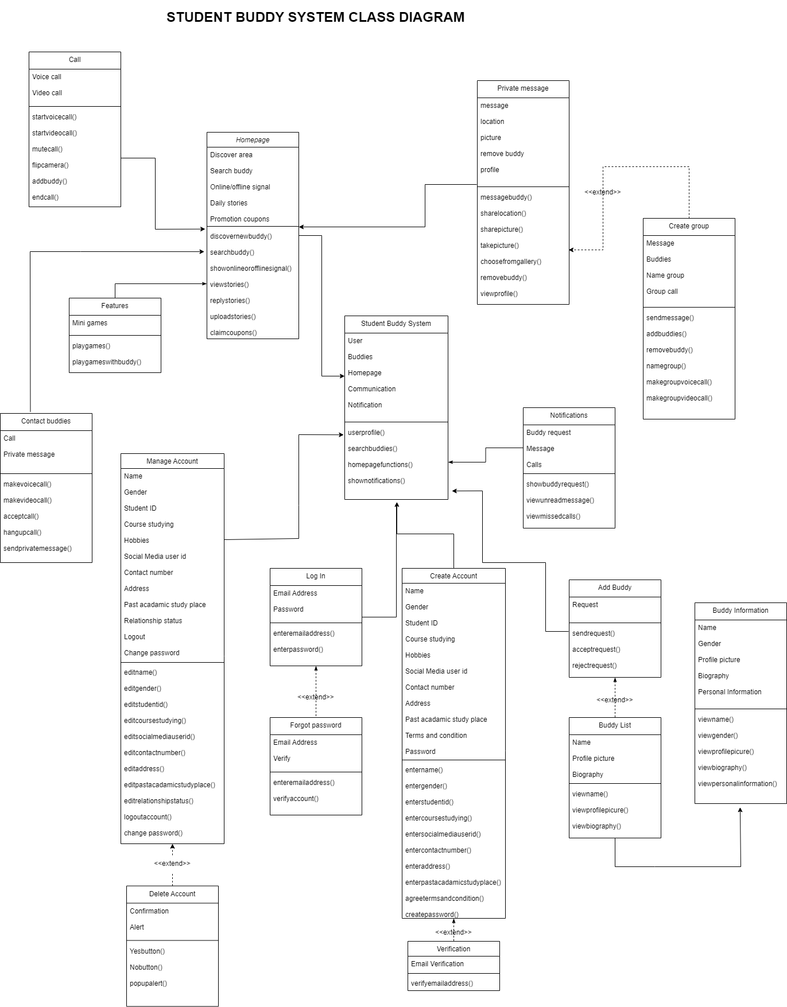

Figure 1 Student Buddy System Class Diagram

An answer to specific software design issues can be found in design patterns. Design patterns are descriptions of, or templates for, solutions to common software development challenges. Creational design patterns, structural design patterns, and behavioural design patterns are the three basic categories of design patterns. The objects generated by these kinds of creational design patterns are tailored to the specific needs of the application. Using structural design patterns, one may quickly grasp how components relate to one another. Finally. The goal of categorising typical communication patterns between items using behavioural design patterns is to maximise the communication's adaptability.

The design pattern chosen to be used in this class diagram is the factory method from the creational patterns. It is possible for subclasses to modify the interface for producing objects in a superclass using the Factory Method creational design pattern. Based on Figure 1, the problem is that the class called Private Message is already have few attributes that has its own function but, it is made for one-to-one user only. By implementing the factory method design pattern, a separate class called Group is made to add another function that can be done for many-to-many conversation. By using this pattern, it helps to keep the design much more organized and easier to understand. Figure 2 shows the diagram where the design pattern.

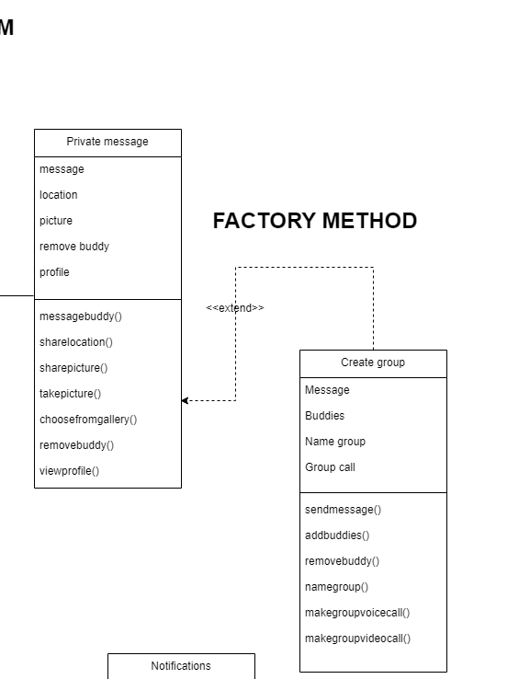

Figure 2 Shows Design Pattern Used